Tinakori:
Critical Journal of the Katherine Mansfield Society
Editors: Kym Brindle and Karen D’Souza
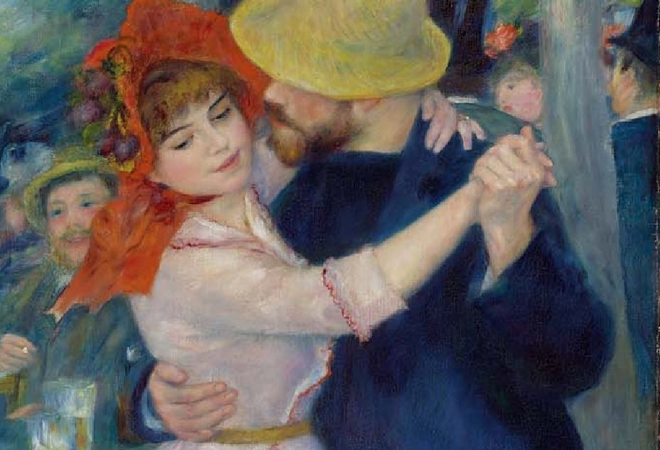

Love
‘About Love. Well each of us thinks differently’
Letter from Mansfield to Dorothy Brett [20 April 1921]

Love and all its passions, pains, and ambiguities is a key theme of Mansfield’s short fiction. This special issue of Tinakori looks to explore Mansfield’s creative treatment of love in all its various forms: between lovers, friends, family members, parents and children. How do Mansfield’s Modernist literary strategies represent the emotions and experiences of love including the pain of separation and the dark shadow that is jealousy? Anne Carson suggests that ‘the experience of eros is a study in the ambiguities of time. Lovers are always waiting. They hate to wait; they love to wait. Wedged between these two feelings, lovers come to think a great deal about time, and to understand it very well, in their perverse way’. How do Mansfield’s stories represent beginnings and endings and separations and reunions – topics that have autobiographical resonance for the writer? What is the significance of time and waiting for love? Do her lovers invent new worlds? In what ways can these be more imagined than real? Can love be ecstatic? Or demonic? This issue seeks to focus on the varied ways that Mansfield explored love as both pain and pleasure.
Suggested topics include, but are not limited to:
- Desire
- Passion
- Jealousy
- Rivalry
- Separation
- Love triangles
- Infatuation
- Fantasy
- Betrayal
- Hope
- Trust
- Possession
- Loss
- Obstacles
- Seduction
- Courtship
- Marriage
Please e-mail abstracts of 500 words to brindlek@edgehill.ac.uk and dsouzak@edgehill.ac.uk by 12 July 2020
Completed essays of 5,000 -6,000 words (including endnotes) in MHRA format due 1 November 2020.
Tinakori: Critical Journal of the Katherine Mansfield Society is an official online series, recognised by the British Library and with its own ISSN number: ISSN 2514-6106.
All essays submitted will be double peer-reviewed prior to acceptance.

Anne Carson, Eros the Bittersweet (New Jersey: Princeton University Press, 2009), p. 117.

