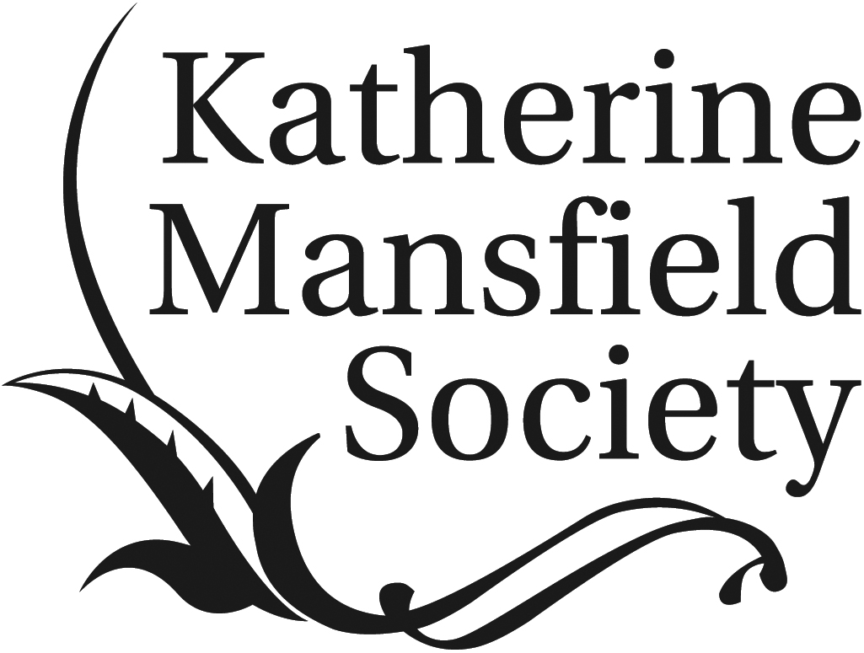

REGISTRATION FORM

KATHERINE MANSFIELD SOCIETY POSTGRADUATE DAY

Monday 10 April 2017

Address of venue:
Seminar Room
The Oxford Research Centre in the Humanities
Radcliffe Humanities
Radcliffe Observatory Quarter
Woodstock Road
Oxford, OX2 6GG

http://www.torch.ox.ac.uk/contact (map)

Please complete these details and return the form to kms@katherinemansfieldsociety.org asap, and no later than the end of March.

Name:
Address:

Email address:

Dietary requirements:
Please indicate whether you have any specific requirements or write N/A (not applicable).

Would you like to attend an informal conference dinner afterwards? (Pay as you go) YES/NO

Registration costs

£15 for KMS members
£30 for non-members, to include a year’s reduced price subscription to the KMS, including a copy of the latest volume of Katherine Mansfield Studies, to be handed out on the day.
NB: TO KEEP COSTS TO A MINIMUM, WE ARE ASKING DELEGATES TO PLEASE PAY IN CASH ONLY ON ARRIVAL AT THE CONFERENCE

